**Sales and Scheduling Test**

Please read the case study and answer the questions below.

* *Please submit only docx and vpp format. Two files only.*
* *Please note that submitted work, in any other format will not be graded.*
* *Your diagrams must be imported to the word document and must be readable with the name tags.*
* *If you don’t have your name tags with* 
  + ***your name,***
  + ***group number***
  + ***student number***
  + ***professor name***
  + ***date, name of the work (inventory test create purchase diagram etc)***

*in the diagrams you will not be graded for that work. (Every diagram should have this information)*

***This test is starting from***

**Wednesday 12th of May @9am**

**till**

**Friday 14th of May @9am**

You are welcome to use additional tools (example Visual Paradigm) as long as you copy pictures of your work into this document. The pictures must be legible. Your professor will not grade any work that isn’t easy to read from the word document.

You are welcome to use outside sources in formulating your answers. Be sure to reference your work using APA format. ***Work not properly referenced will be passed to the Academic Integrity Committee for review.***

Please note that this test is divided into two parts: Sales and Scheduling. Please utilize the case study to answer the question in the Sales part of the test and your week 9 scheduling activity to answer the Scheduling part of the test.

**Part 1: Sales**

**Case Study**

Toronto Cleaners has been offering dry cleaning, sewing and laundry services around the Toronto area since 2010.  Ronny started the business from his home from his garage and moved to his own store once he started growing his business.

Since then, his company has expanded, and he now has a small office space, and number of dry-cleaning stores that she is able to manage.  She has also expanded to same day delivery. Recently, Ronny has started looking into helping industrial dry cleaning and laundry contracts too, such as boutique hotels and AirB&B, as well.

As part of the growth of the company, they are looking into a new management system. Ally, the office manager, needs to be able to quickly and easily invoice clients for dry cleaning services completed.

Industrial clients are invoiced monthly and clients are expected to pay upon receipt of their invoice.

**Your team leader has written the following scenario to capture some of *Toronto Cleaners’*requirements.**

|  |  |  |  |
| --- | --- | --- | --- |
| **Use Case Name** | **Create Invoice** | | |
| Triggering Event | At the end of each week, all dry cleaning and laundry for the week have been evaluated. | | |
| Brief Description | This use case enables the Office Manager to create an invoice for the services rendered for a client during the week. | | |
| Actors | Office Manager | | |
| Related Use Cases |  | | |
| Preconditions | The Office Manager has opened the Billing Menu. | | |
| Post Conditions | The new invoice has been created, saved to the database, and emailed to the client. | | |
| Flow of activities | Actor | | System |
|  | 1 | Requests to record a new invoice | Displays a list of active clients, and prompts for selection. |
|  | 2 | Selects a client | Applies the client information to a new invoice.  Generates a unique invoice number and adds it, and today’s date, to the invoice.  Displays the (incomplete) invoice.  Displays a list of all services, by name. |
|  | 3 | Selects a service | Displays the hourly cost of that service, and prompts for a number of hours. |
|  | 4 | Enters number of hours | Calculates the cost of the service as hourly cost * number of hours.  Displays a list of stores by name |
|  | 5 | Selects the store who completed the service | Adds the invoice detail and the total cost of that line item. |
|  | 6 | Repeats above 3 steps until all services for the week are added | Prompts to print or email |
|  | 7 | Chooses to email | Saves the invoice and all line details. Emails the invoice to the client. |
| Exception Conditions | The Manager chooses to cancel adding the invoice. | | |

**Question 1 (worth 15 marks)**

Create a class diagram that supports the scenario.

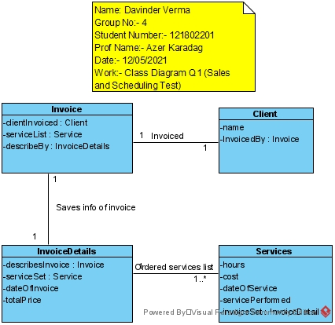3

**Question 2 (worth 20 marks)**

Complete sequence diagrams to support the above scenario.

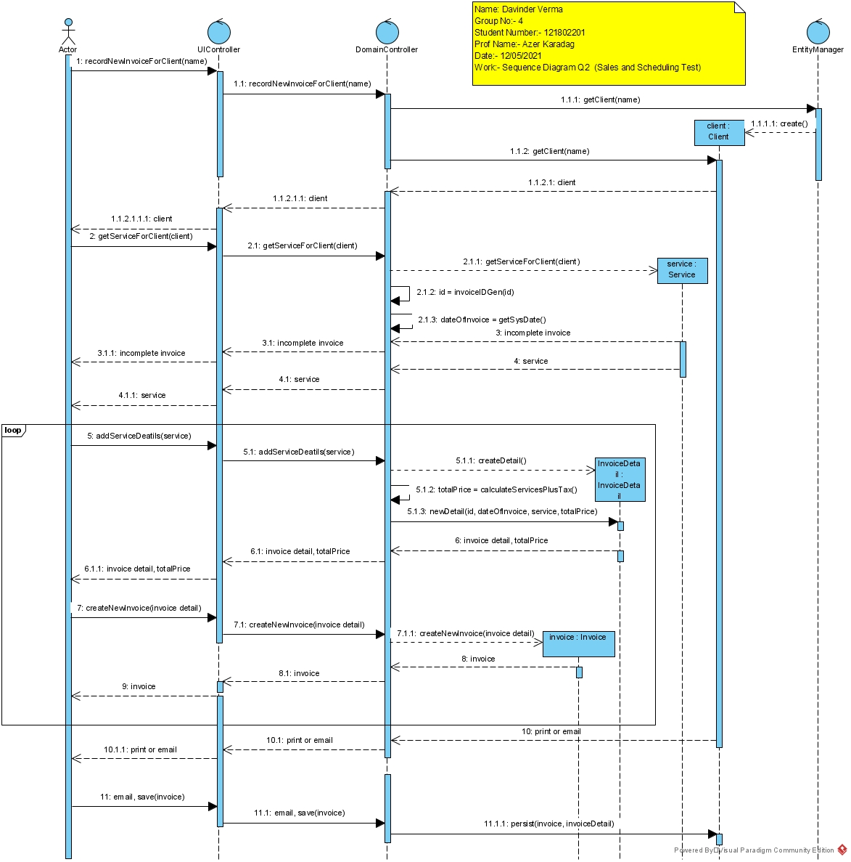

**Question 3 (worth 2 marks)**

***Answer all of the following questions in clear English.***

The above scenario assumes that the hourly cost for a service is the same for each store.  What would happen if the hourly cost changed for each store providing the service?  How would you change your model?

*We will have to change the model to update the hourly cost. For that we will sort the services from the employees and then will calculate the rate. For that we will add a new class which will have all the information of the employee. We will add the attributes such as ID, contact info, price and their specialization. All this information will help us to get the required details for the employee so that we will be able to calculate the hourly rate.*

**Question 4 (worth 2 marks)**

*Toronto Cleaners* is thinking of offering a gift certificate for clients to purchase to give to their friends.  How would you change your model to support this?

*For this we will add a new customer class which will have attributes including a gift card attribute. If before the checkout the records will check if the client is already given the gift card or not. If not, then the client will be given a gift card to give to there friends so that the business grows. The gift card will also be checked before the checkout so that its not used again after being used once.*

**Part 2: Scheduling**

You participated in a scheduling activity as part of week 9. Please use that activity as the case study for this part of the test.

**Question 5 – Class Diagram (worth 10 marks)**

Your task is to create a class diagram to support the activity and the scenario described below. You will be using Toronto Cleaners delivery part.

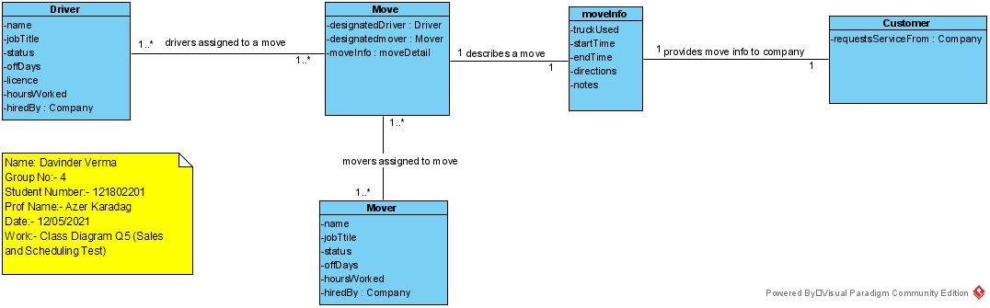

|  |  |  |  |
| --- | --- | --- | --- |
| Use Case Name | Query Scheduled moves of a driver. | | |
| Triggering Event | Driver requests their schedule | | |
| Brief Description | Allows a Driver to request their scheduled moves for the week.  The query must produce an online report displaying the drivers assigned moves, the truck that they are using, the movers assigned to the move, the start time and end time of the move, the directions and notes associated with the move. | | |
| Actors | Driver | | |
| Related Use Cases |  | | |
| Preconditions | Driver has opened the Employee Menu | | |
| Post Conditions | Online report is displayed to the driver. | | |
| Flow of activities | Actor | | System |
|  | 1. | Requests Schedule | Uses login information to retrieve a schedule for the driver for the week. |
| Exception Conditions | * Driver chooses to cancel retrieving their schedule | | |

**Question 6 – Sequence diagram (worth 5 marks)**

Please complete an object level sequence diagram to support the above scenario.

